Manan Shah

22BCE0618  VIT Vellore

Web Programming (BCSE203E) DA 1

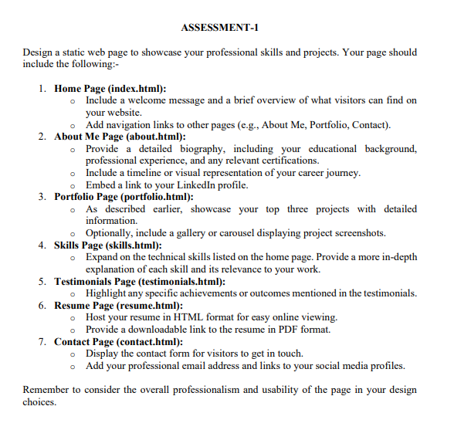

# Home Page (index.html)

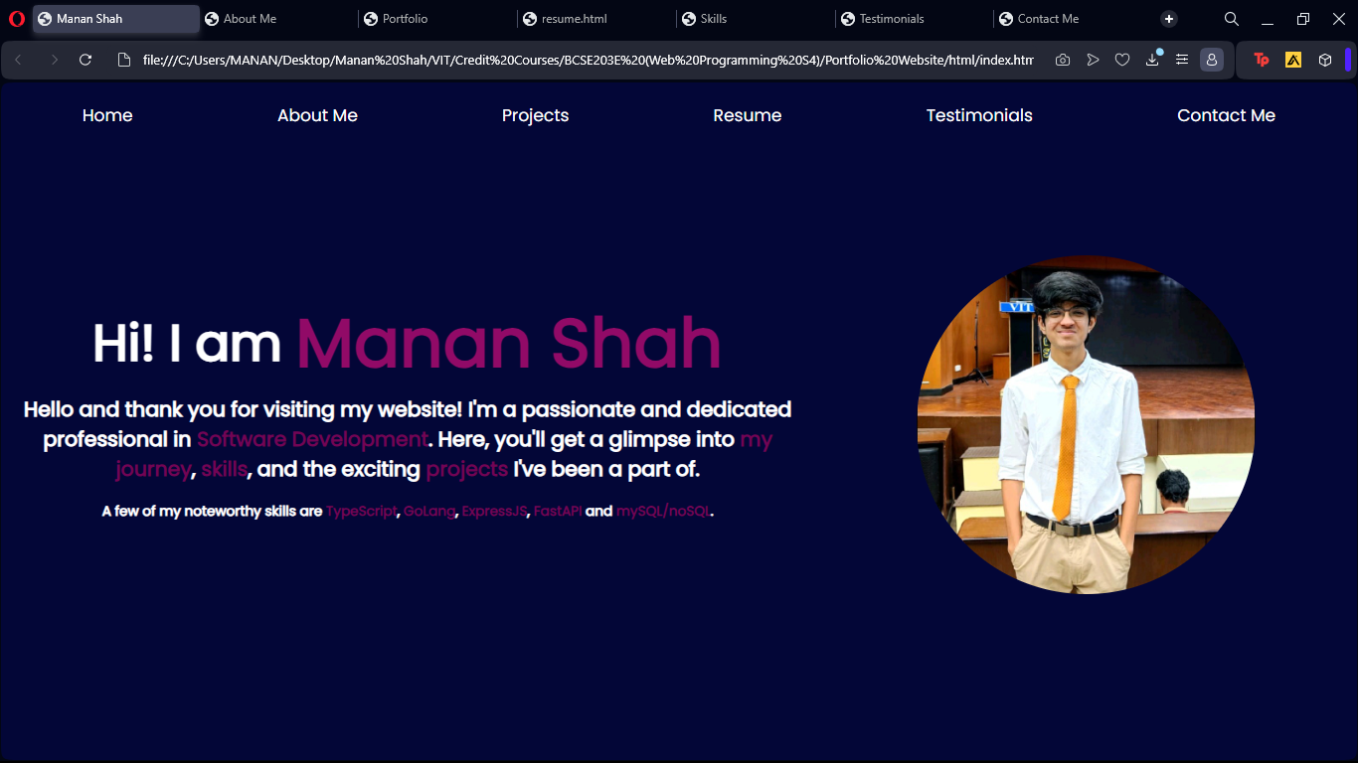

# About Me Page (about.html)

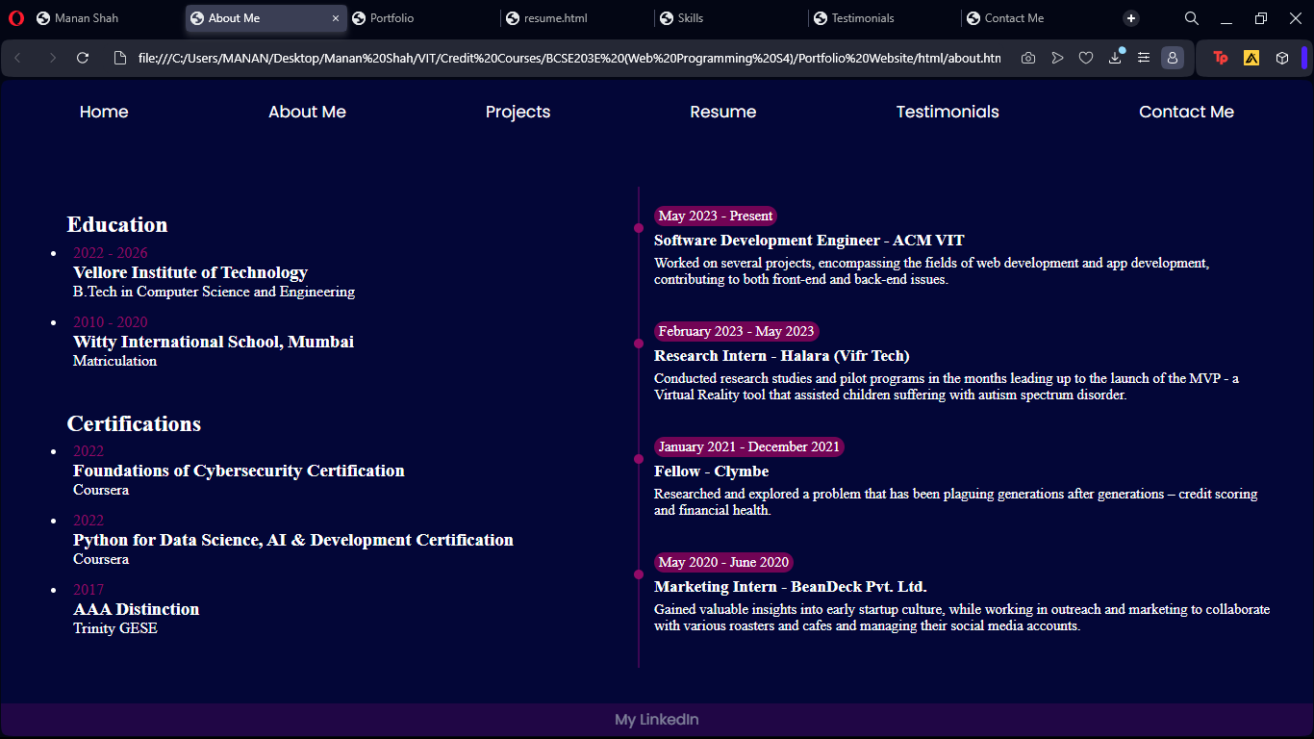

# Portfolio Page (portfolio.html)

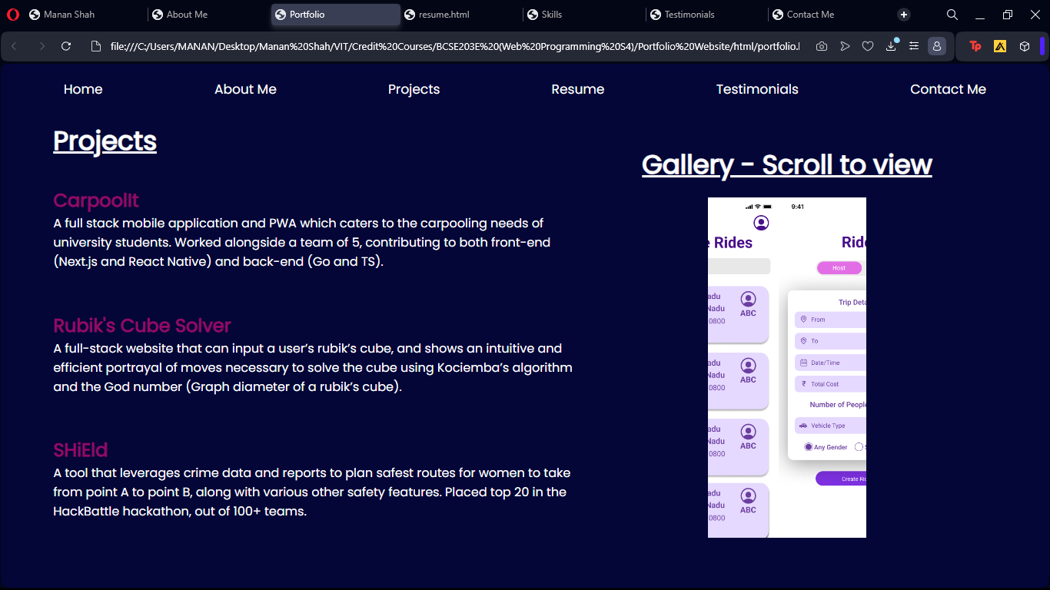

# Skills Page (skills.html)

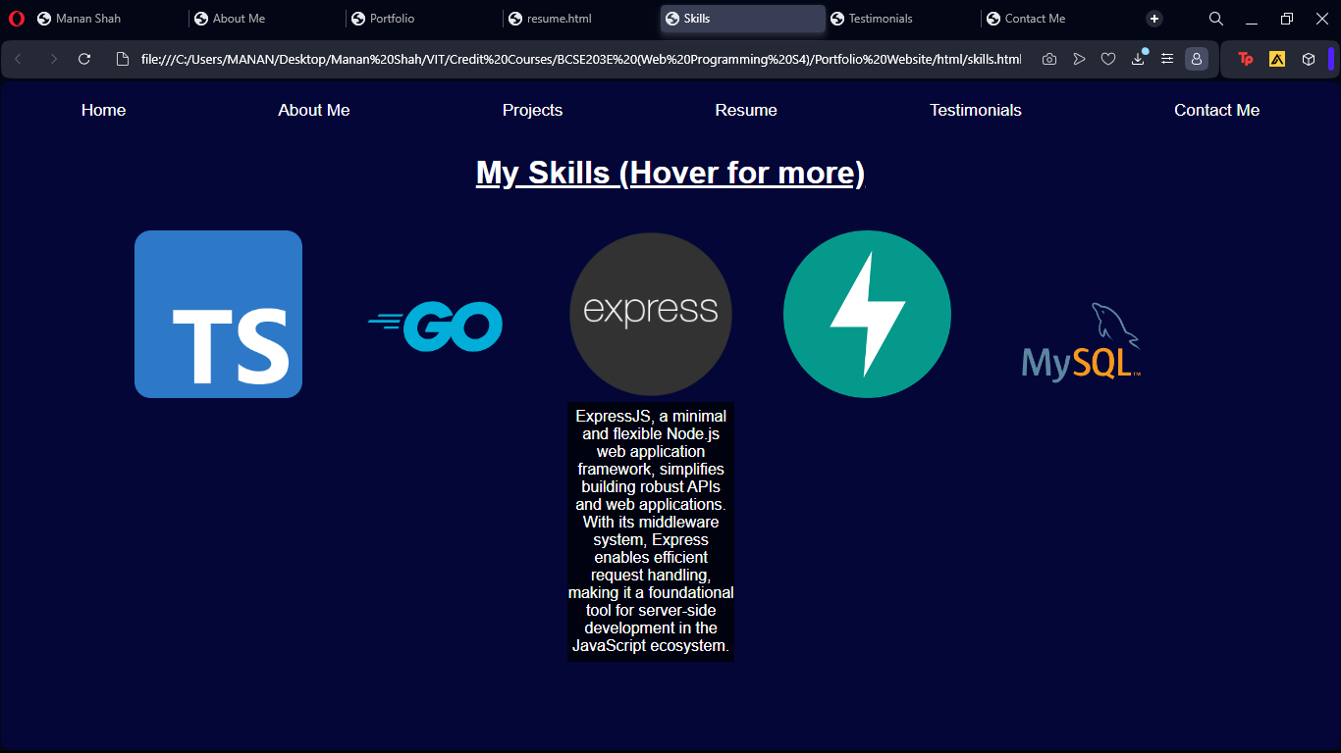

# Testimonials Page (testimonials.html)

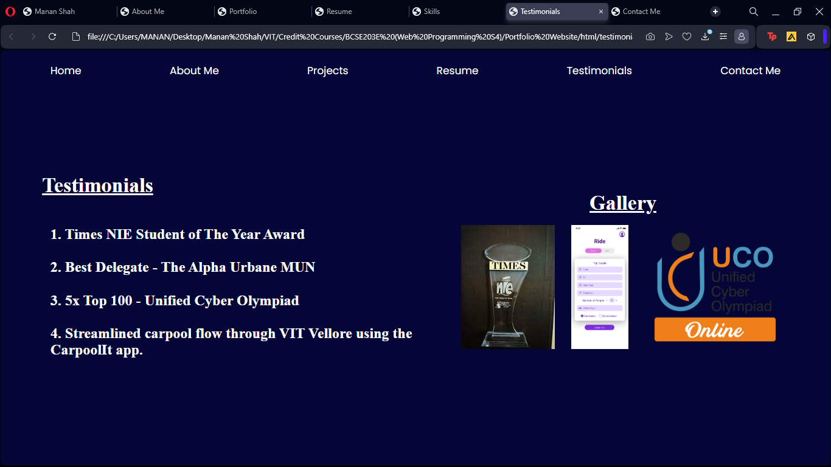

# Resume Page (resume.html)

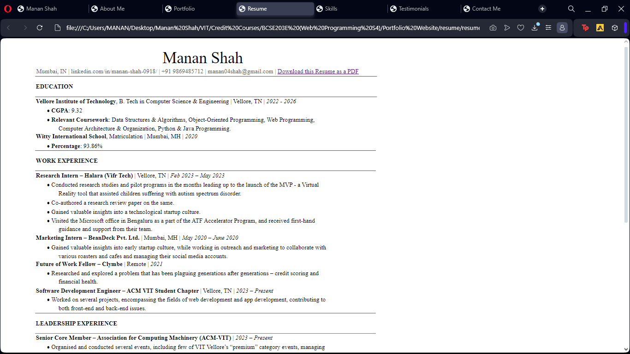

# Contact Page (contact.html)

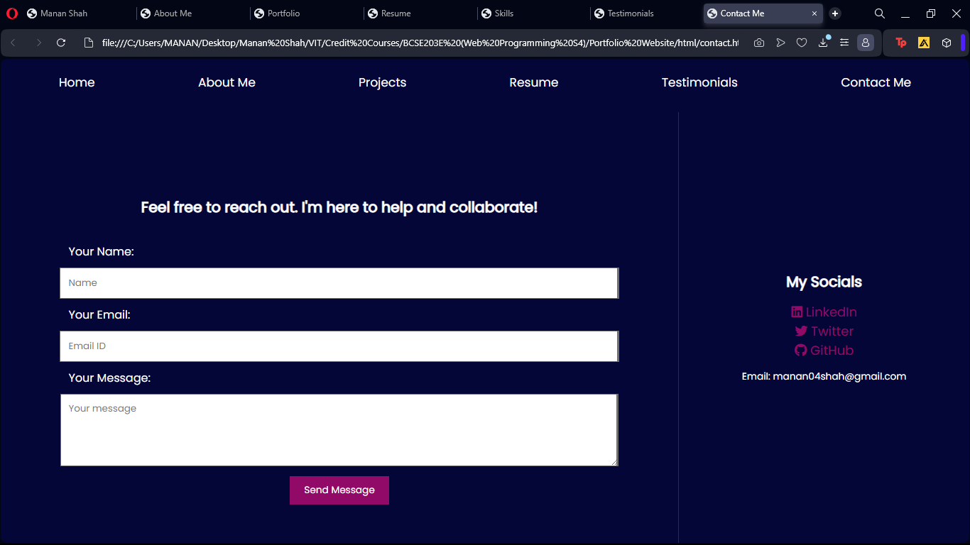

# All the codes are given here, and are also available on the GitHub repository: <https://github.com/manan04shah/bcse203e-web-programming/tree/main/Portfolio%20Website>

*<!-- index.html -->*

<!DOCTYPE html>

<html lang="en">

<head>

    <meta charset="UTF-8">

    <meta name="viewport" content="width=device-width, initial-scale=1.0">

    <title>Manan Shah</title>

    <link rel="stylesheet" href="../styles/index.css">

    <nav>

        <ul>

            <li><a href="index.html">Home</a></li>

            <li><a href="about.html">About Me</a></li>

            <li><a href="portfolio.html">Projects</a></li>

            <li><a href="../resume/resume.html">Resume</a></li>

            <li><a href="testimonials.html">Testimonials</a></li>

            <li><a href="contact.html">Contact Me</a></li>

        </ul>

    </nav>

</head>

<body>

    <div class="container">

        <div class="left-box">

            <div class="left-top">

                <h1 class="welcomeMessage">Hi! I am&nbsp;<div class="name">Manan Shah</div></h1>

            </div>

            <div class="left-bottom">

                <h2 class="overviewMessage">Hello and thank you for visiting my website! I'm a passionate and dedicated professional in <span style="color: #720455;">Software Development</span>. Here, you'll get a glimpse into <span style="color: #720455;">my journey</span>, <span style="color: #720455;">skills</span>, and the exciting <span style="color: #720455;">projects</span> I've been a part of.</h2>

                <br>

                <h3 class="skillsMessage">A few of my noteworthy skills are <span style="color: #720455;">TypeScript</span>, <span style="color: #720455;">GoLang</span>, <span style="color: #720455;">ExpressJS</span>, <span style="color: #720455;">FastAPI</span> and <span style="color: #720455;">mySQL/noSQL</span>.</h3>

            </div>

        </div>

        <div class="right-box">

            <img src="../assets/profileImage.jpeg" alt="Manan Shah Image" class="profileImage">

        </div>

    </div>

</body>

</html>

*/* index.css */*

* {

    margin: 0;

    padding: 0;

}

body {

    background-color: #030637;

}

nav {

    display: flex;

    flex-direction: column;

    justify-content: space-between;

    align-items: center;

    height: 8vh;

    background-color: #030637;

    font-family: 'Poppins', sans-serif;

    padding-top: 3vh;

    padding-left: 5vw;

    padding-right: 5vw;

    margin: 0;

}

ul {

    display: flex;

    justify-content: space-between;

    width: 100%;

    list-style: none;

}

li a{

    padding: 0 1vw;

    color: white;

    text-decoration: none;

    font-size: 2.5vmin;

}

li a:hover {

    color: #910a67;

    transition: 0.25s;

}

.container {

    display: flex;

    height: 89vh;

}

.left-box {

    width: 60vw;

    height: 89vh;

    display: flex;

    flex-direction: column;

    justify-content: center;

    align-items: center;

}

.left-top {

    height: 35vh;

    display: flex;

    flex-direction: column;

    justify-content: flex-end;

    align-items: center;

    width: 100%;

}

.left-bottom {

    height: 54vh;

    display: flex;

    flex-direction: column;

    justify-content: flex-start;

    align-items: center;

    width: 100%;

    text-align: center;

}

.welcomeMessage {

    display: flex;

    flex-direction: row;

    justify-content: center;

    align-items: center;

    color: white;

    font-family: 'Poppins', sans-serif;

    font-size: 7.5vmin;

}

.overviewMessage {

    flex-direction: row;

    justify-content: center;

    align-items: center;

    color: white;

    font-family: 'Poppins', sans-serif;

    font-size: 3vmin;

}

.name {

    color: #910a67;

    font-size: 10vmin;

}

.right-box {

    width: 40vw;

    height: 89vh;

    display: flex;

    flex-direction: column;

    justify-content: center;

    align-items: center;

}

.profileImage {

    width: 25vw;

    height: 25vw;

    border-radius: 50%;

    margin-bottom: 10vh;

}

.skillsMessage {

    flex-direction: row;

    justify-content: center;

    align-items: center;

    color: white;

    font-family: 'Poppins', sans-serif;

    font-size: 2vmin;

}

*<!-- about.html -->*

<!DOCTYPE html>

<html lang="en">

  <head>

    <meta charset="UTF-8" />

    <meta name="viewport" content="width=device-width, initial-scale=1.0" />

    <title>About Me</title>

    <link rel="stylesheet" href="../styles/about.css" />

    <nav>

      <ul class="navigationList">

        <li><a href="index.html">Home</a></li>

        <li><a href="about.html">About Me</a></li>

        <li><a href="portfolio.html">Projects</a></li>

        <li><a href="../resume/resume.html">Resume</a></li>

        <li><a href="testimonials.html">Testimonials</a></li>

        <li><a href="contact.html">Contact Me</a></li>

      </ul>

    </nav>

  </head>

  <body>

    <div class="container">

      <div class="left-box">

        <div class="education">

          <h2>Education</h2>

          <ul>

            <li>

              <span class="date">2022 - 2026</span>

              <div class="content">

                <h3>Vellore Institute of Technology</h3>

                <p>B.Tech in Computer Science and Engineering</p>

              </div>

            </li>

            <li>

              <span class="date">2010 - 2020</span>

              <div class="content">

                <h3>Witty International School, Mumbai</h3>

                <p>Matriculation</p>

              </div>

            </li>

          </ul>

        </div>

        <br>

        <br>

        <div class="education">

            <h2>Certifications</h2>

            <ul>

              <li>

                <span class="date">2022</span>

                <div class="content">

                  <h3>Foundations of Cybersecurity Certification</h3>

                  <p>Coursera</p>

                </div>

              </li>

              <li>

                <span class="date">2022</span>

                <div class="content">

                  <h3>Python for Data Science, AI & Development Certification</h3>

                  <p>Coursera</p>

                </div>

              </li>

              <li>

                <span class="date">2017</span>

                <div class="content">

                  <h3>AAA Distinction</h3>

                  <p>Trinity GESE</p>

                </div>

              </li>

            </ul>

          </div>

      </div>

      <div class="right-box">

        <div class="timeline">

          <ul>

            <li>

              <span>May 2023 - Present</span>

              <div class="content">

                <h3>Software Development Engineer - ACM VIT</h3>

                <p>

                  Worked on several projects, encompassing the fields of web

                  development and app development, contributing to both

                  front-end and back-end issues.

                </p>

              </div>

            </li>

            <li>

              <span>February 2023 - May 2023</span>

              <div class="content">

                <h3>Research Intern - Halara (Vifr Tech)</h3>

                <p>

                  Conducted research studies and pilot programs in the months

                  leading up to the launch of the MVP - a Virtual Reality tool

                  that assisted children suffering with autism spectrum

                  disorder.

                </p>

              </div>

            </li>

            <li>

              <span>January 2021 - December 2021</span>

              <div class="content">

                <h3>Fellow - Clymbe</h3>

                <p>

                  Researched and explored a problem that has been plaguing

                  generations after generations – credit scoring and financial

                  health.

                </p>

              </div>

            </li>

            <li>

              <span>May 2020 - June 2020</span>

              <div class="content">

                <h3>Marketing Intern - BeanDeck Pvt. Ltd.</h3>

                <p>

                  Gained valuable insights into early startup culture, while

                  working in outreach and marketing to collaborate with various

                  roasters and cafes and managing their social media accounts.

                </p>

              </div>

            </li>

          </ul>

        </div>

      </div>

    </div>

  </body>

  <footer>

    <a href="https://www.linkedin.com/in/manan-shah-0918/" target="_blank"><p>My LinkedIn</p></a>

  </footer>

</html>

*/* about.css */*

* {

  margin: 0;

  padding: 0;

}

body {

  background-color: #030637;

}

nav {

  display: flex;

  flex-direction: column;

  justify-content: space-between;

  align-items: center;

  height: 8vh;

  font-family: "Poppins", sans-serif;

  padding-top: 3vh;

  padding-left: 5vw;

  padding-right: 5vw;

  margin: 0;

}

.navigationList {

  display: flex;

  justify-content: space-between;

  width: 100%;

  list-style: none;

}

li a {

  padding: 0 1vw;

  color: white;

  text-decoration: none;

  font-size: 2.5vmin;

}

li a:hover {

  color: #910a67;

  transition: 0.25s;

}

.container {

    display: flex;

    height: 84vh;

}

.left-box {

  width: 45vw;

  height: 84vh;

  display: flex;

  flex-direction: column;

  justify-content: center;

  align-items: flex-start;

  padding-left: 5vw;

}

.right-box {

    width: 55vw;

    height: 84vh;

    display: flex;

    flex-direction: column;

    justify-content: center;

    align-items: center;

}

.timeline {

  width: 50vw;

  color: #fff;

  padding: 20px 20px;

}

.timeline ul {

  list-style-type: none;

  border-left: 2px solid #3c0753;

  padding: 10px 5px;

}

.timeline ul li {

  padding: 10px 10px;

  position: relative;

  cursor: pointer;

  transition: 0.5s;

}

.timeline ul li span {

  display: inline-block;

  background-color: #720455;

  border-radius: 25px;

  padding: 2px 5px;

  font-size: 15px;

  text-align: center;

}

.timeline ul li .content h3 {

  font-size: 17px;

  padding-top: 5px;

}

.timeline ul li .content p {

  padding: 5px 0px 15px 0px;

  font-size: 15px;

}

.timeline ul li:before {

  position: absolute;

  content: "";

  width: 10px;

  height: 10px;

  background-color: #910a67;

  border-radius: 50%;

  left: -11px;

  top: 28px;

  transition: 0.5s;

}

.timeline ul li:hover:before {

  background-color: #0f0;

  box-shadow: 0px 0px 10px 2px #0f0;

}

.education {

    color: white;

}

.education li {

    padding: 1vh 1vh;

}

.date {

    color: #910a67;

}

footer {

    display: flex;

    flex-direction: column;

    justify-content: center;

    align-items: center;

    background-color: #3c0753;

    height: 5vh;

    color: white;

    font-family: "Poppins", sans-serif;

    font-size: 2.25vmin;

    opacity: 50%;

}

footer a {

    color: white;

    text-decoration: none;

}

footer:hover {

    opacity: 100%;

    transition: 0.25s;

}

*<!-- portfolio.html -->*

<!DOCTYPE html>

<html lang="en">

  <head>

    <meta charset="UTF-8" />

    <meta name="viewport" content="width=device-width, initial-scale=1.0" />

    <title>Portfolio</title>

    <link rel="stylesheet" href="../styles/portfolio.css" />

    <nav>

      <ul>

        <li><a href="index.html">Home</a></li>

        <li><a href="about.html">About Me</a></li>

        <li><a href="portfolio.html">Projects</a></li>

        <li><a href="../resume/resume.html">Resume</a></li>

        <li><a href="testimonials.html">Testimonials</a></li>

        <li><a href="contact.html">Contact Me</a></li>

      </ul>

    </nav>

  </head>

  <body>

    <div class="container">

      <div class="left-box">

        <h1>Projects</h1>

        <div class="project">

          <h2>CarpoolIt</h2>

          <p>

            A full stack mobile application and PWA which caters to the

            carpooling needs of university students. Worked alongside a team of

            5, contributing to both front-end (Next.js and React Native) and

            back-end (Go and TS).

          </p>

        </div>

        <div class="project">

          <h2>Rubik's Cube Solver</h2>

          <p>

            A full-stack website that can input a user’s rubik’s cube, and shows

            an intuitive and efficient portrayal of moves necessary to solve the

            cube using Kociemba’s algorithm and the God number (Graph diameter

            of a rubik’s cube).

          </p>

        </div>

        <div class="project">

          <h2>SHiEld</h2>

          <p>

            A tool that leverages crime data and reports to plan safest routes

            for women to take from point A to point B, along with various other

            safety features. Placed top 20 in the HackBattle hackathon, out of

            100+ teams.

          </p>

        </div>

      </div>

      <div class="right-box">

        <h1>Gallery - Scroll to view</h1>

        <div class="gallery">

            <img src="../assets/Available Rides.png" alt="CarpoolIt Screenshot 1">

            <img src="../assets/Host a Ride.png" alt="CarpoolIt Screenshot 2">

            <img src="../assets/Profile Creation.png" alt="CarpoolIt Screenshot 3">

          </div>

      </div>

    </div>

  </body>

</html>

*/* portfolio.css */*

* {

  margin: 0;

  padding: 0;

  font-family: "Poppins", sans-serif;

}

body {

  background-color: #030637;

}

nav {

  display: flex;

  flex-direction: column;

  justify-content: space-between;

  align-items: center;

  height: 8vh;

  background-color: #030637;

  font-family: "Poppins", sans-serif;

  padding-top: 3vh;

  padding-left: 5vw;

  padding-right: 5vw;

  margin: 0;

}

ul {

  display: flex;

  justify-content: space-between;

  width: 100%;

  list-style: none;

}

li a {

  padding: 0 1vw;

  color: white;

  text-decoration: none;

  font-size: 2.5vmin;

}

li a:hover {

  color: #910a67;

  transition: 0.25s;

}

.container {

  display: flex;

  height: 84vh;

}

.left-box {

  width: 45vw;

  height: 84vh;

  display: flex;

  flex-direction: column;

  justify-content: center;

  align-items: flex-start;

  padding-left: 5vw;

}

.right-box {

  width: 55vw;

  height: 84vh;

  display: flex;

  flex-direction: column;

  justify-content: center;

  align-items: center;

}

.left-box h1 {

  font-size: 5vmin;

  color: white;

  text-decoration: underline;

  margin-bottom: 5vh;

}

.project {

  width: 50vw;

  height: 40vh;

  margin-bottom: 5vh;

  border-radius: 5px;

  color: white;

}

.project h2 {

  color: #910a67;

}

.gallery {

  display: flex;

  width: 15.15vw;

  scroll-snap-type: x mandatory;

  white-space: nowrap;

  overflow-x: scroll;

  scrollbar-width: none; */* Hide scrollbar for a cleaner look */*

  -ms-overflow-style: none; */* Hide scrollbar for IE/Edge */*

}

.gallery::-webkit-scrollbar {

  display: none; */* Hide scrollbar for Webkit browsers */*

}

.gallery img {

  max-height: 65vh;

  width: 30vw;

  scroll-snap-align: start;

}

.right-box h1 {

  font-size: 5vmin;

  color: white;

  text-decoration: underline;

  margin-bottom: 2.5vh;

}

*<!-- skills.html -->*

<!DOCTYPE html>

<html lang="en">

  <head>

    <meta charset="UTF-8" />

    <meta name="viewport" content="width=device-width, initial-scale=1.0" />

    <title>Skills</title>

    <link rel="stylesheet" href="../styles/skills.css" />

    <nav>

      <ul>

        <li><a href="index.html">Home</a></li>

        <li><a href="about.html">About Me</a></li>

        <li><a href="portfolio.html">Projects</a></li>

        <li><a href="../resume/resume.html">Resume</a></li>

        <li><a href="testimonials.html">Testimonials</a></li>

        <li><a href="contact.html">Contact Me</a></li>

      </ul>

    </nav>

  </head>

  <body>

    <h1 style="color: white; text-align: center; text-decoration: underline;">My Skills (Hover for more)</h1>

    <div class="skills-container">

      <div class="skill-box" data-description="TypeScript">

        <img src="../assets/typescript.png" alt="TypeScript" />

        <div class="description">

          TypeScript is a statically-typed superset of JavaScript, enhancing

          code reliability and maintainability. Its type annotations provide

          clear documentation, catching errors during development. TypeScript is

          valuable in large codebases, ensuring more robust software

          architecture.

        </div>

      </div>

      <div class="skill-box" data-description="GoLang">

        <img src="../assets/golang.png" alt="GoLang" />

        <div class="description">

          GoLang is a statically-typed, compiled language designed for

          simplicity and efficiency. With a focus on readability and

          concurrency, Go excels in building scalable, high-performance systems.

          Its fast compilation and built-in support for concurrent programming

          make it an ideal choice for modern software development.

        </div>

      </div>

      <div class="skill-box" data-description="ExpressJS">

        <img src="../assets/expressjs.png" alt="ExpressJS" />

        <div class="description">

          ExpressJS, a minimal and flexible Node.js web application framework,

          simplifies building robust APIs and web applications. With its

          middleware system, Express enables efficient request handling, making

          it a foundational tool for server-side development in the JavaScript

          ecosystem.

        </div>

      </div>

      <div class="skill-box" data-description="FastAPI">

        <img src="../assets/fastapi.png" alt="FastAPI" />

        <div class="description">

          FastAPI is a modern, fast (high-performance), web framework for

          building APIs with Python 3.7+ based on standard Python type hints.

          Leveraging asynchronous programming, FastAPI allows developers to

          create efficient and scalable APIs. Its automatic OpenAPI and JSON

          Schema generation streamline documentation and client integration.

        </div>

      </div>

      <div class="skill-box" data-description="mySQL">

        <img src="../assets/mysql.png" alt="mySQL" />

        <div class="description">

          MySQL, an open-source relational database management system, is a

          cornerstone for storing and retrieving data in software development.

          Renowned for its reliability, scalability, and extensive feature set,

          MySQL is widely used in applications ranging from small projects to

          large-scale enterprise solutions.

        </div>

      </div>

    </div>

  </body>

</html>

*/* skills.css */*

* {

  margin: 0;

  padding: 0;

  font-family: "Popins", sans-serif;

}

body {

  background-color: #030637;

}

nav {

  display: flex;

  flex-direction: column;

  justify-content: space-between;

  align-items: center;

  height: 8vh;

  background-color: #030637;

  font-family: "Poppins", sans-serif;

  padding-top: 3vh;

  padding-left: 5vw;

  padding-right: 5vw;

  margin: 0;

}

ul {

  display: flex;

  justify-content: space-between;

  width: 100%;

  list-style: none;

}

li a {

  padding: 0 1vw;

  color: white;

  text-decoration: none;

  font-size: 2.5vmin;

}

li a:hover {

  color: #910a67;

  transition: 0.25s;

}

.skills-container {

  display: flex;

  justify-content: space-between;

  align-items:baseline;

  flex-wrap: wrap;

  gap: 10px;

  width: 80vw;

  height: 65vh;

  margin: 20px auto;

  padding: 20px;

}

.skill-box {

  flex: 1 0 12.5vw; */* Responsive width for each box */*

  overflow: hidden;

  position: relative;

}

.skill-box img {

  width: 12.5vw;

  height: auto;

  transition: transform 0.3s;

}

.description {

  position: relative;

  bottom: 0;

  left: 0;

  width: 12.5vw;

  background: rgba(0, 0, 0, 0.7);

  color: #fff;

  text-align: center;

  padding-top: 1vh;

  padding-bottom: 1vh;

  opacity: 0;

  transition: opacity 0.3s;

}

.skill-box:hover .description {

  opacity: 1; */* Display description on hover */*

}

*<!-- testimonials.html -->*

<!DOCTYPE html>

<html lang="en">

  <head>

    <meta charset="UTF-8" />

    <meta name="viewport" content="width=device-width, initial-scale=1.0" />

    <title>Testimonials</title>

    <link rel="stylesheet" href="../styles/testimonials.css" />

    <nav>

      <ul>

        <li><a href="index.html">Home</a></li>

        <li><a href="about.html">About Me</a></li>

        <li><a href="portfolio.html">Projects</a></li>

        <li><a href="../resume/resume.html">Resume</a></li>

        <li><a href="testimonials.html">Testimonials</a></li>

        <li><a href="contact.html">Contact Me</a></li>

      </ul>

    </nav>

  </head>

  <body>

    <div class="container">

      <div class="left-box">

        <h1>Testimonials</h1>

        <div class="project">

          <h2>1. Times NIE Student of The Year Award</h2>

        </div>

        <div class="project">

          <h2>2. Best Delegate - The Alpha Urbane MUN</h2>

        </div>

        <div class="project">

          <h2>3. 5x Top 100 - Unified Cyber Olympiad</h2>

        </div>

        <div class="project">

          <h2>

            4. Streamlined carpool flow through VIT Vellore using the CarpoolIt

            app.

          </h2>

        </div>

      </div>

      <div class="right-box">

        <h1>Gallery</h1>

        <div class="gallery">

          <img src="../assets/nie.jpeg" alt="CarpoolIt Screenshot 1" />

          <img src="../assets/Host a Ride.png" alt="CarpoolIt Screenshot 2" />

          <img

            src="../assets/uco.png"

            alt="CarpoolIt Screenshot 3"

          />

        </div>

      </div>

    </div>

  </body>

</html>

*/* testimonials.css */*

* {

  margin: 0;

  padding: 0;

}

body {

  background-color: #030637;

}

nav {

  display: flex;

  flex-direction: column;

  justify-content: space-between;

  align-items: center;

  height: 8vh;

  background-color: #030637;

  font-family: "Poppins", sans-serif;

  padding-top: 3vh;

  padding-left: 5vw;

  padding-right: 5vw;

  margin: 0;

}

ul {

  display: flex;

  justify-content: space-between;

  width: 100%;

  list-style: none;

}

li a {

  padding: 0 1vw;

  color: white;

  text-decoration: none;

  font-size: 2.5vmin;

}

li a:hover {

  color: #910a67;

  transition: 0.25s;

}

.container {

  display: flex;

  height: 84vh;

}

.left-box {

  width: 45vw;

  height: 84vh;

  display: flex;

  flex-direction: column;

  justify-content: center;

  align-items: flex-start;

  padding-left: 5vw;

}

.right-box {

  width: 55vw;

  height: 84vh;

  display: flex;

  flex-direction: column;

  justify-content: center;

  align-items: center;

}

.left-box h1 {

  font-size: 5vmin;

  color: white;

  text-decoration: underline;

  margin-bottom: 5vh;

}

.project {

  width: 50vw;

  margin: 2vh;

  border-radius: 5px;

  color: white;

}

.project h2 {

  color: white;

}

.project h2:hover {

    color: #910a67;

    transition: 0.25s;

}

.gallery {

  display: flex;

  flex-direction: row;

  gap: 2vw;

}

.gallery img {

    height: 30vh;

    width: auto;

    max-width: 20vw;

}

.right-box h1 {

  font-size: 5vmin;

  color: white;

  text-decoration: underline;

  margin-bottom: 2.5vh;

}

*<!-- contact.html -->*

<!DOCTYPE html>

<html lang="en">

  <head>

    <meta charset="UTF-8" />

    <meta name="viewport" content="width=device-width, initial-scale=1.0" />

    <title>Contact Me</title>

    <link rel="stylesheet" href="../styles/contact.css" />

    <link

      rel="stylesheet"

      href="https://cdnjs.cloudflare.com/ajax/libs/font-awesome/6.0.0-beta3/css/all.min.css"

    />

    <nav>

      <ul>

        <li><a href="index.html">Home</a></li>

        <li><a href="about.html">About Me</a></li>

        <li><a href="portfolio.html">Projects</a></li>

        <li><a href="../resume/resume.html">Resume</a></li>

        <li><a href="testimonials.html">Testimonials</a></li>

        <li><a href="contact.html">Contact Me</a></li>

      </ul>

    </nav>

  </head>

  <body>

    <div class="container">

      <div class="left-box">

        <div class="left-bottom">

          <h2 class="overviewMessage">

            Feel free to reach out. I'm here to help and collaborate!

          </h2>

          <br />

          <form action="#" method="POST" class="contact-form">

            <label for="name">Your Name:</label>

            <input

              type="text"

              id="name"

              name="name"

              placeholder="Name"

              required

            />

            <label for="email">Your Email:</label>

            <input

              type="email"

              id="email"

              name="email"

              placeholder="Email ID"

              required

            />

            <label for="message">Your Message:</label>

            <textarea

              id="message"

              name="message"

              rows="4"

              placeholder="Your message"

              required

            ></textarea>

            <button type="submit">Send Message</button>

          </form>

        </div>

      </div>

      <div class="right-box">

        <h2>My Socials</h2>

        <div class="social-links">

          <a href="linkedin.com/in/manan-shah-0918/" target="_blank">

            <i class="fab fa-linkedin"></i> LinkedIn

          </a>

          <a href="https://twitter.com/mananshahhh__" target="_blank">

            <i class="fab fa-twitter"></i> Twitter

          </a>

          <a href="https://github.com/manan04shah" target="_blank">

            <i class="fab fa-github"></i> GitHub

          </a>

        </div>

        <p class="email">Email: manan04shah@gmail.com</p>

      </div>

    </div>

  </body>

</html>

*/* contact.css */*

* {

    margin: 0;

    padding: 0;

    font-family: 'Poppins', sans-serif;

}

body {

    background-color: #030637;

}

nav {

    display: flex;

    flex-direction: column;

    justify-content: space-between;

    align-items: center;

    height: 8vh;

    background-color: #030637;

    font-family: 'Poppins', sans-serif;

    padding-top: 3vh;

    padding-left: 5vw;

    padding-right: 5vw;

    margin: 0;

}

ul {

    display: flex;

    justify-content: space-between;

    width: 100%;

    list-style: none;

}

li a{

    padding: 0 1vw;

    color: white;

    text-decoration: none;

    font-size: 2.5vmin;

}

li a:hover {

    color: #910a67;

    transition: 0.25s;

}

.container {

    display: flex;

    height: 89vh;

}

.left-box {

    width: 70vw;

    height: 89vh;

    display: flex;

    flex-direction: column;

    justify-content: center;

    align-items: center;

}

.left-bottom {

    height: 54vh;

    display: flex;

    flex-direction: column;

    justify-content: flex-start;

    align-items: center;

    width: 100%;

    text-align: center;

}

.welcomeMessage {

    display: flex;

    flex-direction: row;

    justify-content: center;

    align-items: center;

    color: white;

    font-family: 'Poppins', sans-serif;

    font-size: 7.5vmin;

}

.overviewMessage {

    flex-direction: row;

    justify-content: center;

    align-items: center;

    color: white;

    font-family: 'Poppins', sans-serif;

    font-size: 3vmin;

}

.name {

    color: #910a67;

    font-size: 10vmin;

}

.right-box {

    width: 30vw;

    height: 89vh;

    display: flex;

    flex-direction: column;

    justify-content: center;

    align-items: center;

    border-left: 1px solid #720455;

}

.contact-form {

    display: flex;

    flex-direction: column;

    justify-content: center;

    align-items: center;

    width: 100%;

}

.contact-form label,

.contact-form textarea,

.contact-form input {

    width: 80%;

    padding: 10px;

}

.contact-form textarea {

    resize: vertical;

}

.contact-form button {

    background-color: #910a67;

    color: white;

    padding: 10px 20px;

    border: none;

    cursor: pointer;

    font-size: 2vmin;

    margin-top: 2vh;

}

.contact-form button:hover {

    background-color: #720455;

    transition: 0.25s;

}

.right-box .social-links {

    display: flex;

    flex-direction: column;

    align-items: center;

    margin: 2vh;

    font-size: large;

}

.right-box .social-links a:hover {

    text-decoration: underline;

    transition: 0.25s;

}

.right-box .social-links a {

    color: #910a67;

    text-decoration: none;

}

.right-box .email {

    color: white;

    font-size: 2vmin;

}

label {

    color: white;

    text-align: left;

}

.right-box h2 {

    color: white;

    font-size: 3vmin;

}